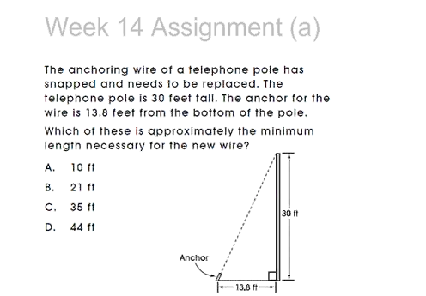

The correct answer is C.

13.8^2 + 30^2 = 1090.44

Sq rt of 1090.44 = 33.02

A^2 + B^2 = C^2